Name: _______________________________________________ June 2016
All assignments are due on Monday, June 6. Late assignments will not be accepted.
Part A: Draw each of the following structures in any form you choose. [12 pts]
- 2, 3-dimethylnonane

- 4-methyl-2-pentyne

- 2,2,4-trimethyl-5-propyl- 3-octene

- 3,5-dimethylcyclohexene

- 2-methyl-1-pentene

- cyclopropane

- cis-3-hexene

- 4-cyclobutyl-6-ethyl-2,5-dimethylnonane

- 1, 3-diethylbenzene

- 4-ethyl-5-phenyl-2-heptyne

- 3,5-dimethylcyclodecene

- 3,4,6-triethyl-5,7-dimethyl-1-nonyne

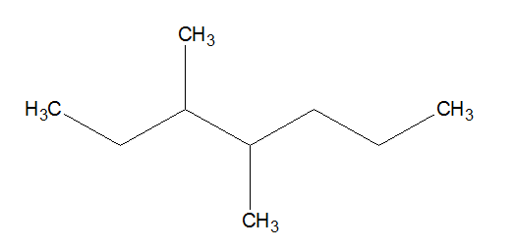 | 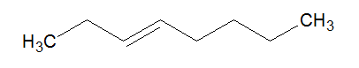
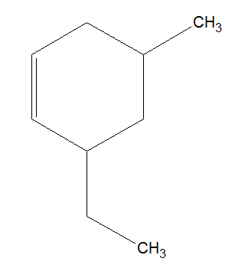 | 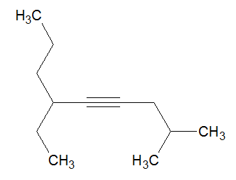
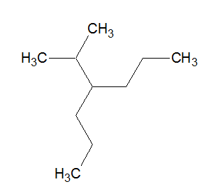 | 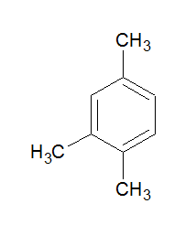
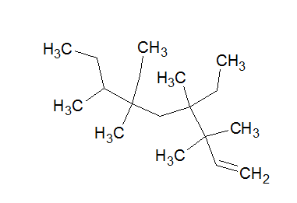 | 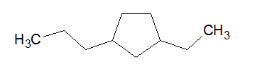
Part B: Name each of the following compounds [8 pts]

Part C – Answer these questions on a separate piece of paper. Attach it to the assignment before submitting it.
- Draw and name all isomers of the molecule with the formula C₅H₁₀. [9 pts]

- Determine if each of the following names are correct. For incorrect names, provide the corrected name and a structural drawing of your choice. [6 pts]
  - 2, 3–diethyl–4–propyloctane
  - 5-ethyl-2,3-dimethylheptane
35
  - 2, 3, 3–trimethylbutane

