Step 1: Get your data into Excel.
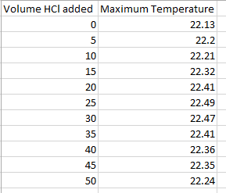
First, you need to input your data into Excel. The independent variable should be in the first column and the dependent variable in the second column. You do not have to include the units at this point.

Step 2: Choose a type of chart/graph to create.
In Excel, you have plenty of choices for charts and graphs to create. For most science graphs, a scatterplot is the best choice. It allows you to see trends and perform various types of regression (making the equation of the line of best fit).
Go to the ‘Insert’ tab, and choose the graph you wish. For this lab, you will choose the first option that comes up for scatter plot.
Step 3: Create the graph.
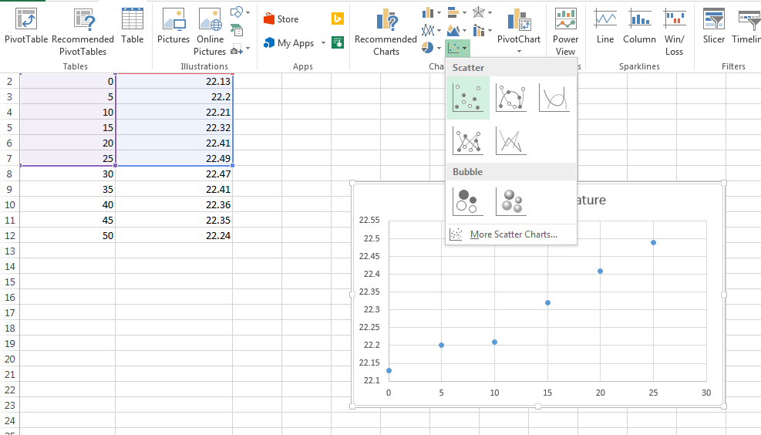
Select ALL of the data you wish to graph. For this lab, choose all data where the temperature is increasing. This will instantly create a graph. You will add the data where temperature is decreasing in a separate step.

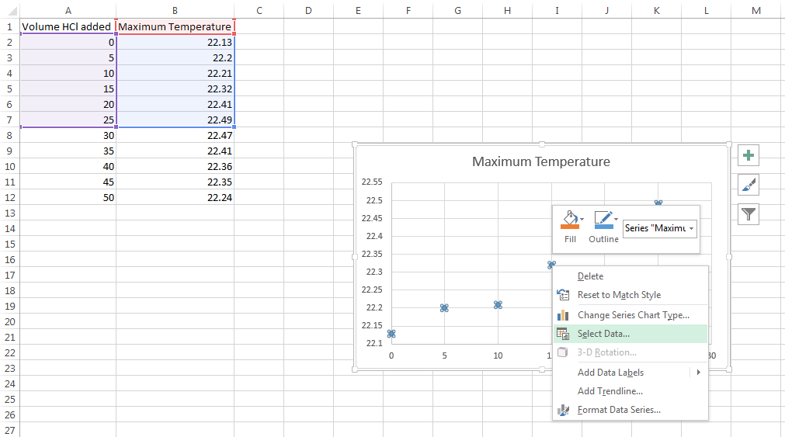
Step 4: Adding the additional data.

Right-click on any data point on the graph produced in the previous step. On the drop-down menu, select ‘Select Data…”

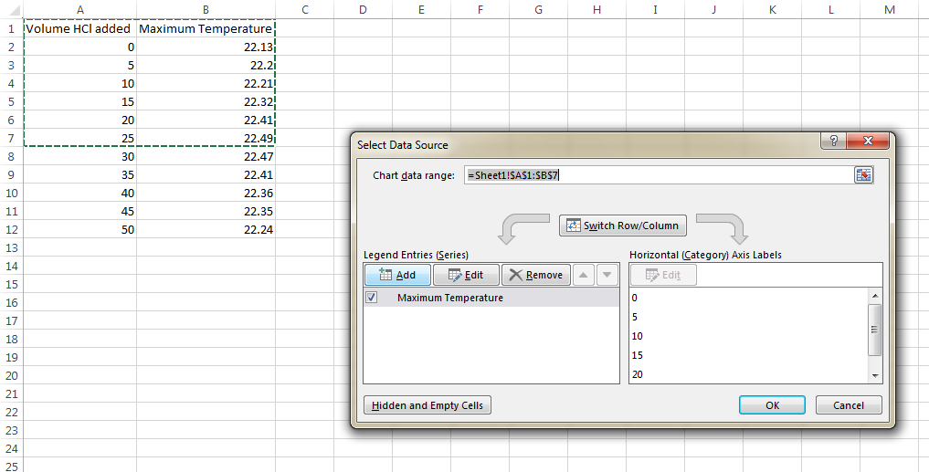
In the dialog box that pops up, select “Add” from the Legend Entries (Series). This will prompt you to add new data from the sheet originally used to generate the graph.

Selecting Add will prompt the Edit Series dialog box. Type any ‘Series name’ of your choosing in the first space.
To add data, click on the icon under the ‘Series X values’ box. This will redirect you to the source data for the graph. In the ‘Edit Series’ dialog box, click the icon. This will now allow you to select the remaining data for the graph. Repeat for the ‘Series Y values’.
When all the remaining data is selected, click OK in the dialog box. All values should now be present.

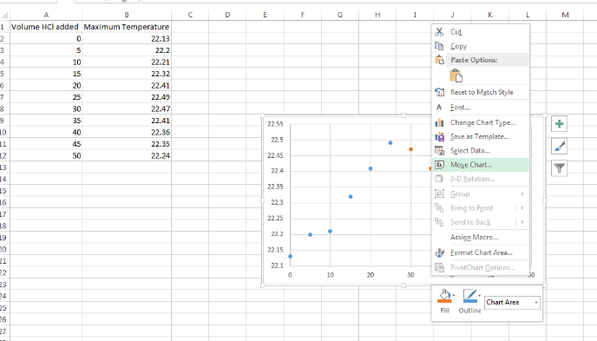
Step 5: Move the chart location.

The chart will be easier to read and work with (and you are required to do so for your lab) if you have it as a new sheet in your workbook rather than as an object in an existing sheet. Right click on the chart and select ‘Move Chart’.

When asked to choose where you want the chart to be placed, click ‘New sheet’ and give the sheet a title if you wish.

Step 6: Adjust your labels and legends.
To change the layout of the labeling and legend, click on the graph, then click the ‘Design’ tab and then Select Chart Element. Here you can choose what layout you prefer for the chart title, axis titles, and legend among others. Add the elements you need and give them appropriate titles that include units of measurement.

You can delete the legend for this graph. Legends are helpful when you have more than one set of data on the same chart.

Step 7: Generate Lines of Regression.
You want to generate regression lines for each data series on the graph. These are lines of best fit that may not cross every point. To insert a line of best fit, right-click on any data point for the first set of points and select ‘Add Trendline…’.
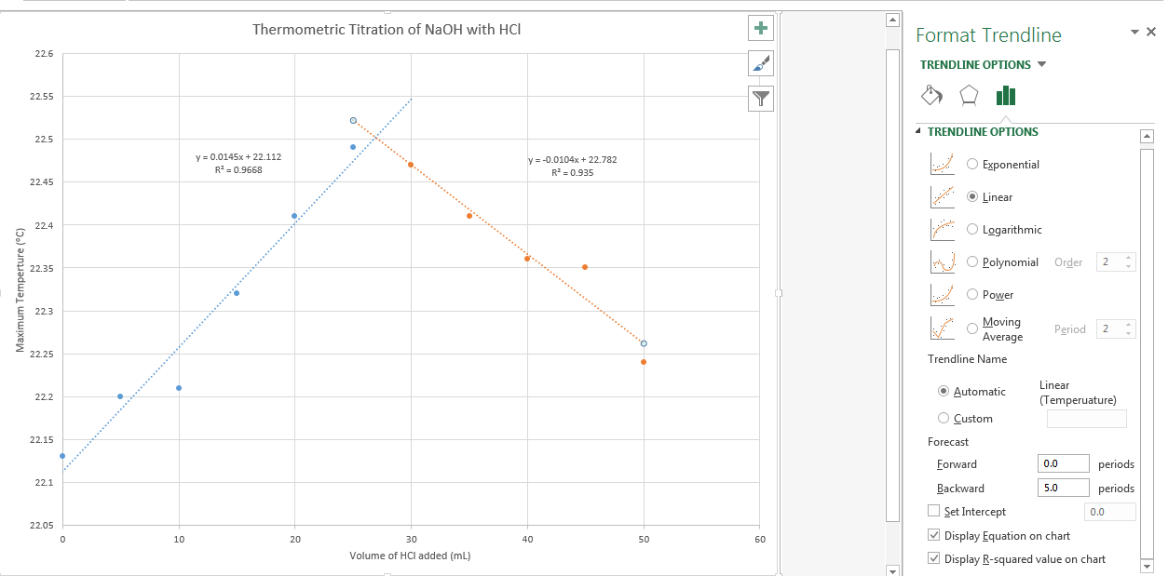
In the Format Trendline Options, select ‘Linear’ as the type. The equation of the line and the R-squared values (which says how good of a fit the line is) need to be displayed.
To get the line to extend so that you can see the point of intersection, you can forecast it forward or backward. Where the temperture is increasing, it should be forecast forward and where it is decreasing, it should be forecasted backward.
Step 8 – Print the graph.
Print your graph as a full page. Because it is a unique sheet in the workbook this will be the default setting. Black and white is fine.

