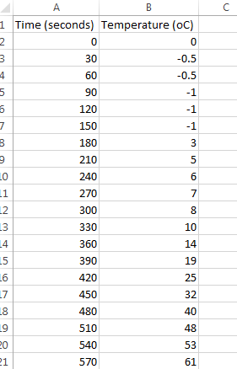
Step 1: Get your data into Excel.
First, you need to input your data into Excel. The independent variable should be in the first column and the dependent variable in the second column. You do not have to include the units at this point.

Step 2: Choose a type of chart/graph to create.
In Excel, you have plenty of choices for charts and graphs to create. For most science graphs, a scatterplot is the best choice. It allows you to see trends and perform various types of regression (making the equation of the line of best fit).
Go to the ‘Insert’ tab, and choose the graph you wish. For this lab, you will choose the first option that comes up for scatter plot.
Step 3: Create the graph.
Select ALL of the data you wish to graph. You can also add more data points if you wish but it is easier if you simply choose it all at once. After the data is selected, click the chart option you choose in step 2. This will instantly create a graph.
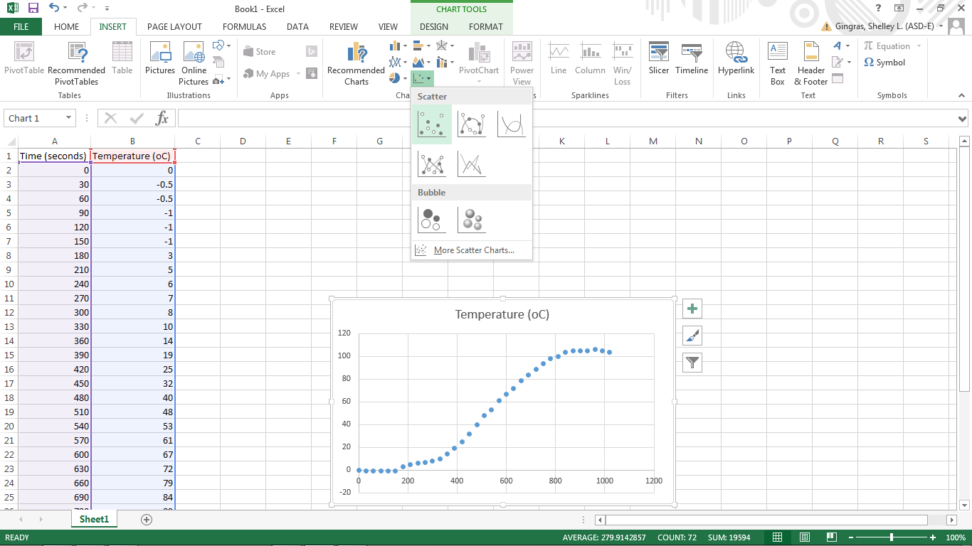

Step 4: Move the chart location.

The chart will be easier to read and work with (and you are required to do so for your lab) if you have it as a new sheet in your workbook rather than as an object in an existing sheet. Right click on the chart and select ‘Move Chart’.

When asked to choose where you want the chart to be placed, click ‘New sheet’ and give the sheet a title if you wish.

Step 4: Adjust your labels and legends.
To change the layout of the labeling and legend, click on the graph, then click the ‘Design’ tab and then Select Chart Element. Here you can choose what layout you prefer for the chart title, axis titles, and legend among others. Add the elements you need and give them appropriate titles that include units of measurement.
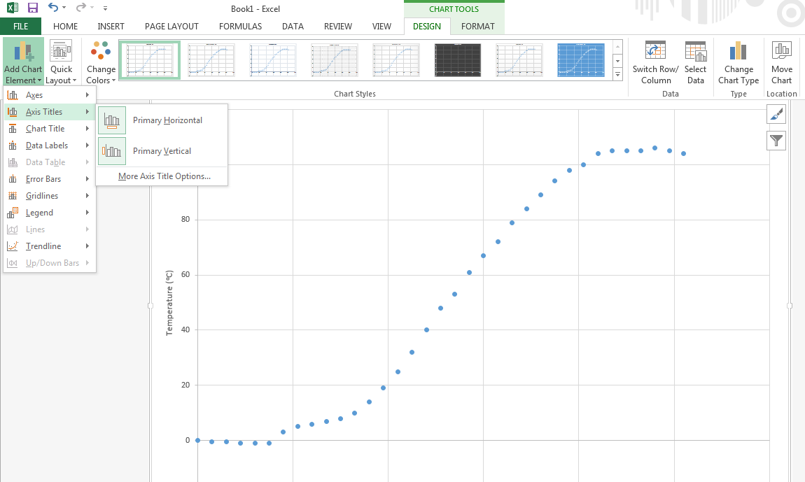

You can delete the legend for this graph. Legends are helpful when you have more than one set of data on the same chart.

Step 5: Generate a Smooth Line.
You want to connect the dots with a smooth line that is not a regression line or line of best fit. To do this, right click on any data point and select ‘Format Data Series’.
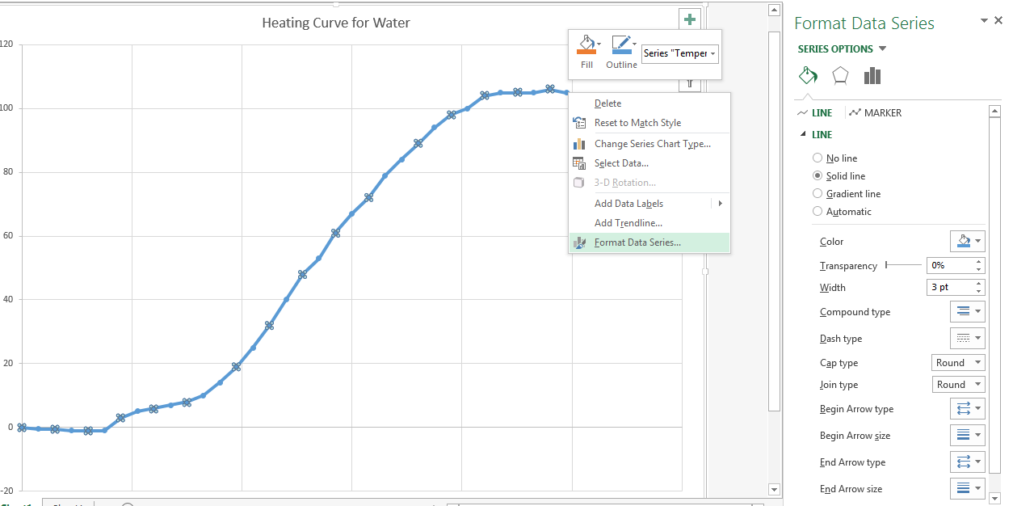
Under the fill options, select ‘Solid line’ and adjust the color and width if needed. This will automatically create a smooth line connecting all points on the graph.
Step 6 – Print the graph.
Print your graph as a full page. Because it is a unique sheet in the workbook this will be the default setting. Black and white is fine.

