- Complete the table below. Elements with more than one blank have variable charge. Include ALL options. Refer to Table 9.2 on Page 255 of your text book if you are stuck.
Element | Dot Structure | Ion Dot Structure | Ion Name
Barium
Calcium
Carbon
Iron
Lead
Lithium
Oxygen
Phosphorous
Silver
Sulphur
Zinc

- Write the formula unit for the compounds formed when the following pairs of elements form an ionic bond.
Elements | Formula Unit
- Barium and phosphorous
- Sodium and carbon
- Lead and oxygen (both compounds)
- Zinc and sulphur
- Iron and phosphorous (both compounds)
- Silver and sulphur
- Calcium and carbon
- Lithium and oxygen

SOLUTIONS
- Complete the table below. Elements with more than one blank have variable charge. Include ALL options. Refer to Table 9.2 on Page 255 of your text book if you are stuck.
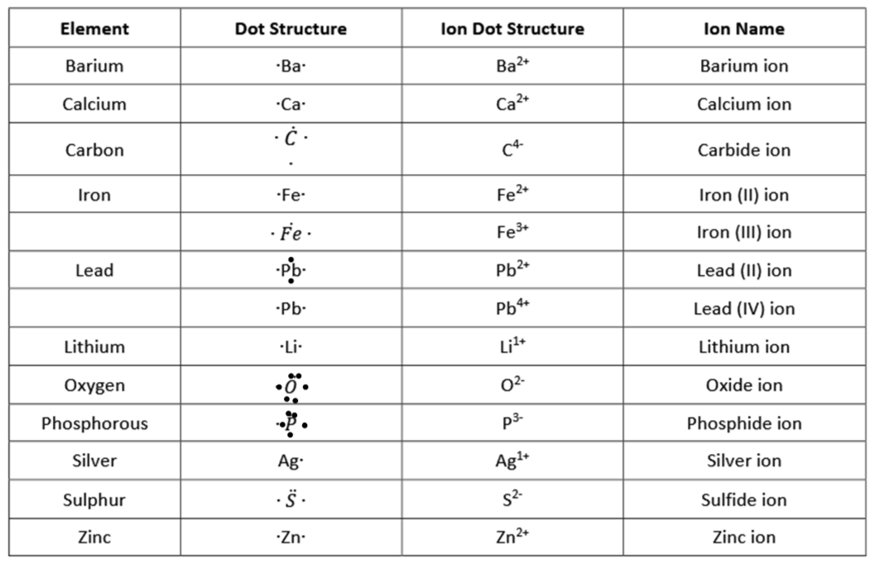
- Write the formula unit for the compounds formed when the following pairs of elements form an ionic bond.
Elements | Formula Unit
- Barium and phosphorous | Ba₃P₂
- Sodium and carbon | Na₄C
- Lead and oxygen (both compounds) | Pb₂O₃
 | PbO₂
- Zinc and sulphur | ZnS
- Iron and phosphorous (both compounds) | Fe₃P₂
 | FeP
- Silver and sulphur | Ag₂S
- Calcium and carbon | CaC₂
- Lithium and oxygen | Li₂O

